**RegressIt Analysis**  
  
RegressIt is menu-driven and easy to use add-on tool that can be added to excel for quick linear regression and multivariate analysis. As per their official documentation (<https://regressit.com/get-started-with-analysis.html>), the following steps can be followed to reproduce the given example or try hands-on learning.  
  
**1.  Launch Excel and load your data**:  open the data file you wish to use, or else type or copy-and-paste data onto the first worksheet in a blank file.  The data should be arranged columnwise with text labels in the first row that are to be used as variable names.  
  
**2. Launch RegressIt by opening the program file**

**3.  Name your variables (first time only):**  hit the **SELECT DATA**button on the menu, which ought to select the whole data range automatically, and then hit the **CREATE NAMES** button, as indicated in the picture below.   You will see a pop-up box with four checkboxes for locations of the names, and **you should check only the "Top row" box**. This will assign the text labels in row 1 as variable names (Excel range names) for the data underneath them. Here are a few more details for text data:

* The variable lists for descriptive statistics and regression models will show only variables that have one or more numerical values in their columns**.  If some of your variables are encoded in text form, you won't see them in the dialog boxes.**  Dates, for example, are sometimes encoded as text rather than numerical values ("2005Q1", "2005Q2"...).  If this is the case and you want to treat them as numbers, you will need to recode them in number format (2005.0, 2005.25...) or Excel date format before trying to assign names.
* If some variables are text labels for categories, say, a variable called Sex with values "Male" and "Female", RegressIt will not automatically recognize them as such.  However, you can use its **﻿**[**variable transformation tool**](https://regressit.com/variable-transformations.html) ﻿to instantly create dummy (0-1)  variables for them with default names such as Sex.Eq.Male and Sex.Eq.Female, of which one or the other could be used as an independent variable. This tool will show you the full list of variables to choose from, even those that are all text.  It can be launched from the descriptive stats or regression dialog boxes.

**4.  Save your file** under the name you want to use for the master copy of your not-yet-analyzed data set.

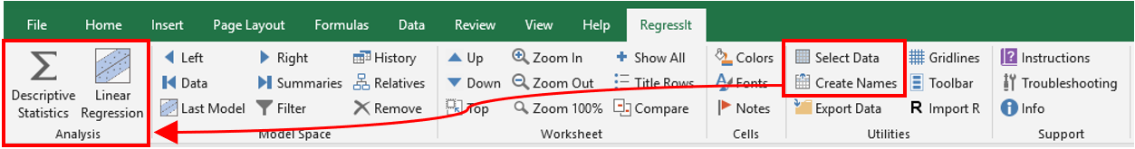

*Now for some analysis…*  
  
**5.** If you want to get summary statistics, correlations, and plots of your data, click the **DESCRIPTIVE STATISTICS** button on the RegressIt menu as shown above.  This will open a dialog box with a list of your variables and options for descriptive analysis. This procedure will always generate a descriptive statistics table and a correlation matrix, and there are options for some additional statistics and various kinds of plots.  **Select your variables, click the boxes of any optional outputs you would like, and hit Run.**A new worksheet will be created with the results, and initially it will be displayed in collapsed form with only header rows showing.  **Hit the SHOW ALL button on the RegressIt menu, or click the plus signs next to the header rows, to open up the tables and display all the results.**  If you toggle the **COLORS**button on the menu, you can turn on color-coding for the correlations according to their sign and magnitude.    
  
**6. Save your file under a new name at this point.**   
  
7. If you want to fit a regression model, hit the **LINEAR REGRESSION** button on the menu.  This will open up the linear regression dialog box. **Choose your variables and the optional outputs you would like to get, then hit Run.**  The results will be generated on a new worksheet.  If you do not choose any options, you will get minimal output. **Save your file** (again).